Abigail Cosgrove
Dr. Pressman
ECL 522
December 15, 2024
The Counterpane: An Explanation of a Dance Adaptation
The Dance
Part dance, part poem, part experience, this project is an adaptation of the movement in Moby Dick that explores how being in a state of exhaustion is where the mind is the least clear and the most available for change. This state of mind is a very turbulent one, full of decision making, where the other can become familiar and stagnation can result in death. By sinking into those moments, letting himself feel but also fighting the urge to become sedentary, Ishmael is able to harness this mental state and adapt to new circumstances. I will be looking at two instances of this- first in the chapter “The Counterpane,” with Ishmael’s half awake brain making sense of the way the quilt, him, and Queequeg all mesh together, in direct contrast to their almost violent meeting. The second is in the two chapters “Stubb Kills A Whale” and “The Dart,” where the shift from idleness to exhaustion to endurance is the make or break for the characters’ life or death. These scenes are far apart and in no way encompass the whole book, however, by collaging them together in my own body I can make my own version of the counterpane: A state of mind where bias can change and endurance either succeeds or fails at keeping the body going.
There are three main steps to this adaptation process. The first was finding a way to catalog my experience while reading the book, and then use the moments I found most interesting to generate movement later. The second step was creating whatever experience I wanted to facilitate while dancing, which is my score. The third step is performing the dance, and seeing what revelations come from doing so. At the end of all of this, I will have adapted select moments from Moby Dick and reinterpreted the book in the process. Any time I found a similar thread between what I was making and Moby Dick’s form, or my own creative process, I would lean into it. While I made it, over the course of the semester, I in no way could see my end product. Now, looking back, it gets a lot clearer.
How It Got Started: Prereading
I was inspired by a section from Andrew Delblanco’s introduction to the book that talked about the chapter “The Counterpane”; he writes,
“In the bed they share in the Spouter Inn, Queequeg’s tattooed arm lies across the quilted counterpane that covers Ishmael’s chest, and in the first waking moments, when the line between consciousness and unconsciousness remains indeterminate, Ishmael feels himself dissolve into the flesh and fabric that are touching him. He cannot distinguish between Queequeg’s arm and the quilt, or even between his own body and the coverings that press upon it. Through this liberating confusion he relives a childhood experience (whether dream or reality he cannot say) in which he had waked from an enforced sleep that had been his punishment for trying to climb up the chimney. Dimly making out in the darkness his hand hanging off of the bed, he had not known it as his own; it seemed an alien object clasped in the hand of some threatening phantom, and he had not dared try to move it to see if it were free to be withdrawn. He feared breaking the uncertainty as much as submitting to it, and under the spell of fright and fascination, he transformed his stepmother’s anger into guilt. This was the moment, he seems now to realize, in which he discovered the proscribed otherness of his body and the world it craved.
Having relieved this discovery, it is through the uninvited intimacy with Queequeg that Ishmael begins to unlearn his guilt. The reversal goes quickly, and he becomes both terrified and exhilarated by his new freedom.” (Andrew Delbanco xvii)
This scene is genius because Ishmael doesn’t learn to let go of his prejudices by talking it out, but by meditating with it. It’s a foggy moment where he is half stuck in a dream, reliving the fear and guilt of a past version of himself, and the only thing that grounds him is the strange man he shares a bed with. In a half awake state where he can believe he is still stuck in his room from being grounded and also right there with Queequeg, he is able to ask himself other things. Why should he fear this man? Why shouldn’t he be comforted by his presence? Isn’t he just another human body too?
When one can consider their reality altered, they can begin to consider what belongs in reality, and what their reality is. Maybe reality is that an arm can blend into a blanket, into another arm, into tattooed ink. Maybe reality is where two men of different races can touch and think nothing of it. It all seems a lot less crazy when the absurd logic of dreams becomes bigger than fear. I began to ask the question, when I came back to this quote, how has Ishmael changed after this experience? How, by distorting his sense of time in the presence of someone he considers “other” and accepting that as reality, prepared him for his grueling life as a whaler?
To answer these questions, I set out to make an adaptation that also served as a sort of experiment. By using my notes and having cataloged my experience of the book, I could make an adaptation of the mental and physical journey Ishmael experiences, and see if I could reach some sort of similar conclusion, epiphany, or any type of revelation. In an essay by Jerome McGann, called “The Great Final Hash of Moby-Dick” he writes,
“Moby-Dick declares at the start that it is made from what was earlier made in other books. The parodies therefore serve a significant double function: they show the conscious artistic purpose at work with materials that are rich with inherited meanings, and they provide readers with a rhetorical ground for an equivalent model of reading.” (McGann)
Whatever conclusion I came to after performing, I hoped it would reveal to me something about the book I didn’t know, and something about myself I didn’t know. Moreover, I wanted my audience to be able to experience this revelation through me, as well. They didn’t have to be from the class or know anything about the novel, since it’s not imperative we come to the same conclusion. If they had watched me, and through my experience discovered something, I would have done the experiment correctly.
But First, Ethics: Setting Up for Success by Setting Up Failure
While I am calling this project an “experiment,” in making it I hadn’t figured out what that exactly meant yet. Can this process count as a scientific method? If it is, then when making it, I wanted to make sure my test subjects were treated ethically: the audience and myself. Both of these can be taken care of at the same time: by avoiding making this project about finding pain, or producing shock. This dance is close to masochism, and I wanted to stop many steps before that; I gave myself room in the dance to stop, make mistakes, and to give the audience a break from the growing tension. I think the fault of this project is how I got a little too close to idealizing Melville’s writing process, which is a few steps further into idolization than I intended.
I strongly believe this self reflection is vital because my goal is to offer an experience to myself and anyone who watches, not to produce a single emotion or outcome. If someone finds my dance shocking, or boring, then they are interpreting it that way. If I wanted shock or boredom to be the single outcome, I would’ve hit my head on the desk 50 times or knocked myself out. The dance isn’t about watching me suffer, it is about watching me explore.
Making the Dance: The Movement, The Score, and The Structure
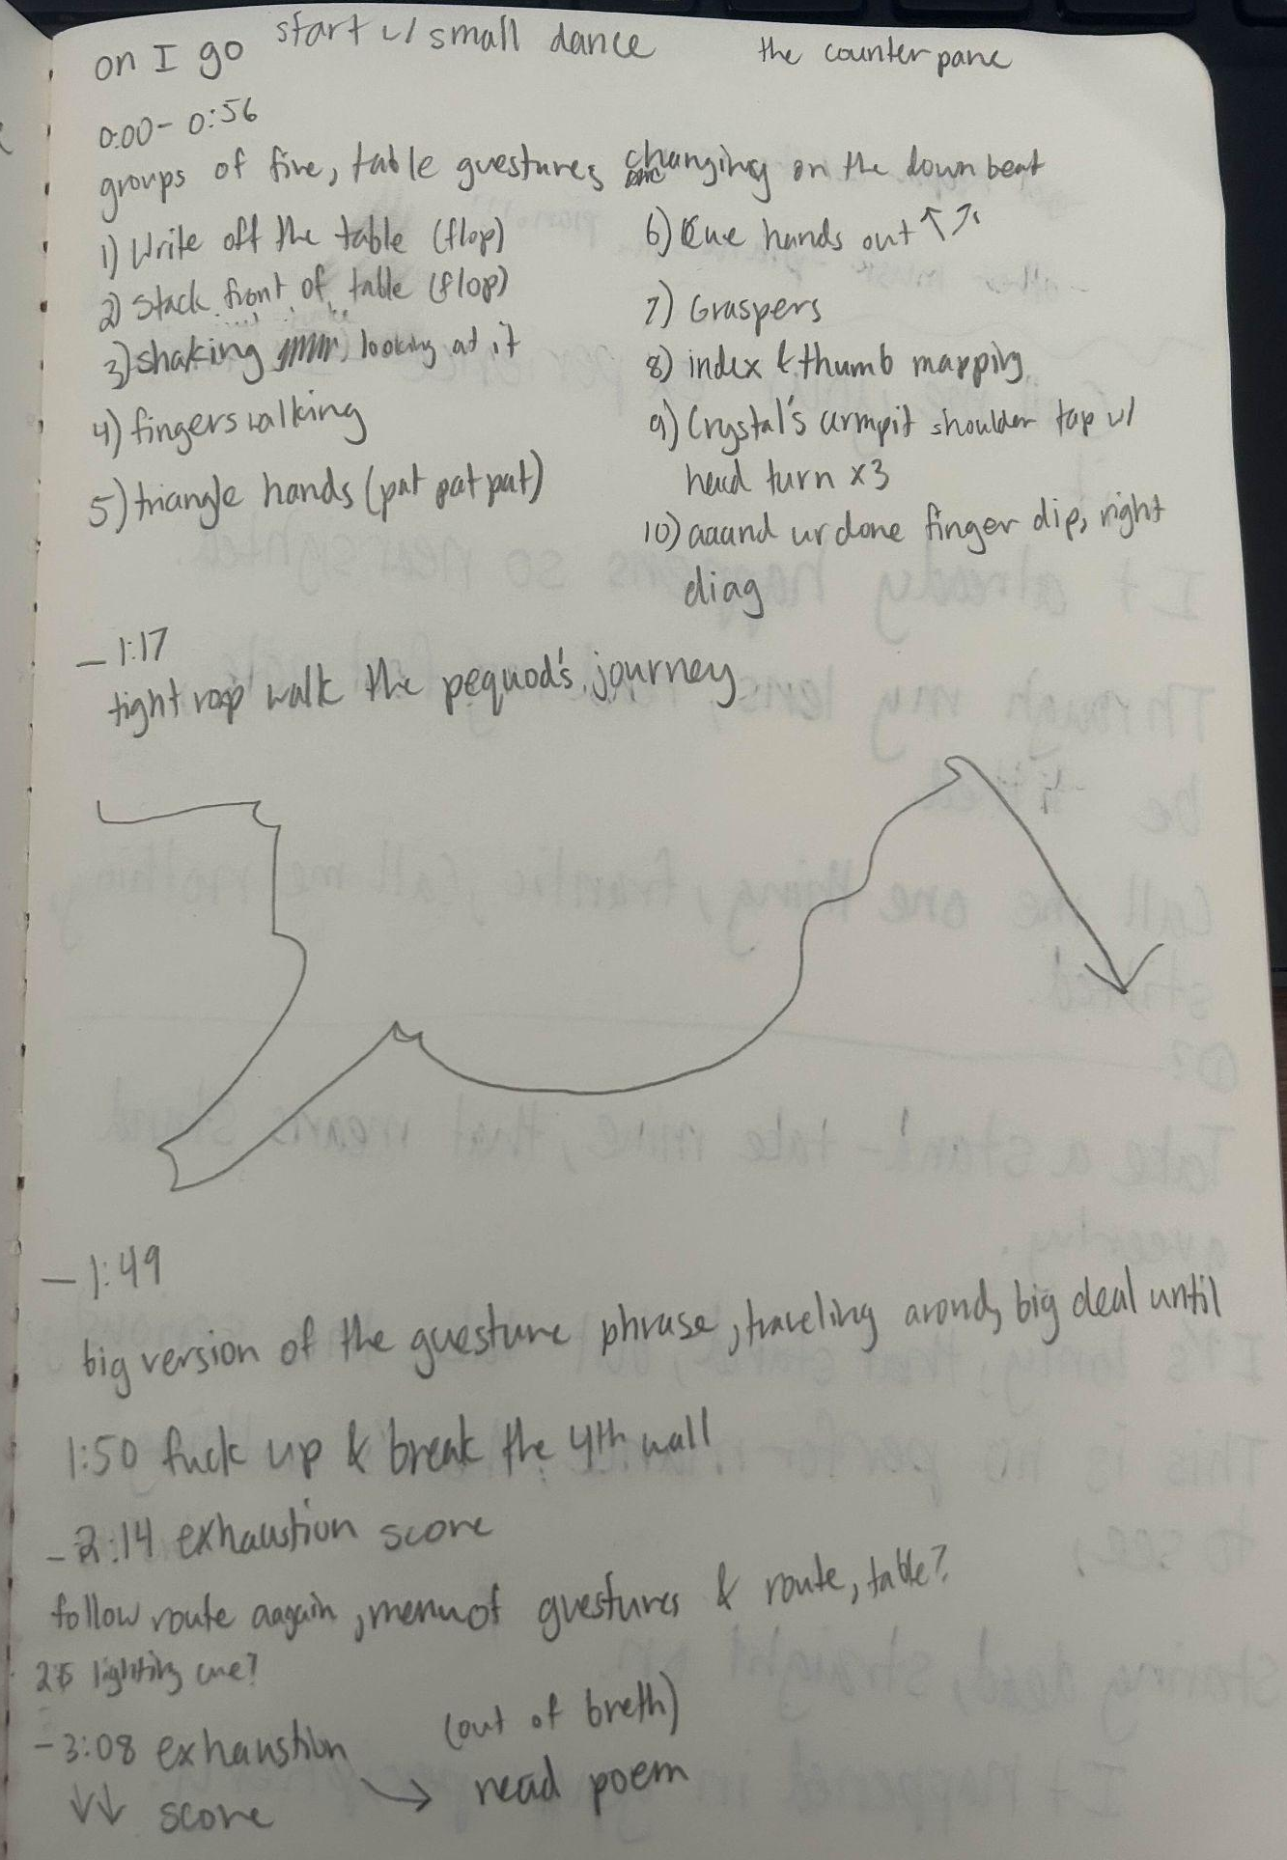
At the beginning of the semester, I already knew I wanted to dance for my final, so I started and worked on several elements as a way to keep a diary of my reactions, and anything I found interesting. These elements were the poem I wrote, a gesture phrase, and the structure of the dance being based off of the Fiona Apple song “On I Go.” My initial prompt for all of the dance elements was, “add more movement where it is already present and highlight the movement already present.” In “On I Go” the same lyrics are repeated over and over again, with a few breaks in the song where the instrumentals shift.
The song, if you are interested: Fiona Apple - On I Go (Official Audio)
I used those breaks as sections and wrote the dance out in my notebook shown above.
The first section was at the table, composed of ten movements I had written down in my notes during class throughout the semester. Essentially, whenever I spoke in class, if I used my hands to make a gesture to help me visualize what I was saying, I would note it and describe what it was. Once we finished the book, I collected and tweaked them into these 10 moves:
MD Gestures.MOV
I do them in order at the table, and I kept the notebook with me on the table since I didn’t have them memorized yet. I ended up liking the look of me struggling to read them, so I kept that in the dance. The only one that really stayed the same was the thumb and index mapping, which I believe I did in class to show a compass protractor charting a course. Then, I got up from the table and walked an abbreviation of the Pequod’s course, found in the back of the book. The last section is the exhaustion phrase, where I did the 10 gestures as a standing movement as quickly as I remembered and repeated as many times as it took me to find the order again. There is a part in “On I Go” where Fiona Apple messes up the lyrics, so in the dance I take that as my moment to be overwhelmed with my mental strain of trying to perform something I don’t fully know and “mess up.” After that, the exhaustion score starts again and ends with the music. Finally, I read the poem as my preplanned “epiphany.”
I’ll call this rehearsal run “Round One” of my experiment: MD Rehearsal Run.MOV
What I found after this run and talking to my teacher Jessica Humphrey was that the Fiona Apple really took up the stage and it was hard to see that the dance was about anything else. In many ways, I consider Fiona Apple to be my version of Melville and Shakespeare. So, I ended up opting to use a live pianist and singing the song in my head, adding to the difficulty of my memorization. I also decided to switch the order of my poem’s stanzas.
Speaking of the Poem: It Is Also Called “The Counterpane”
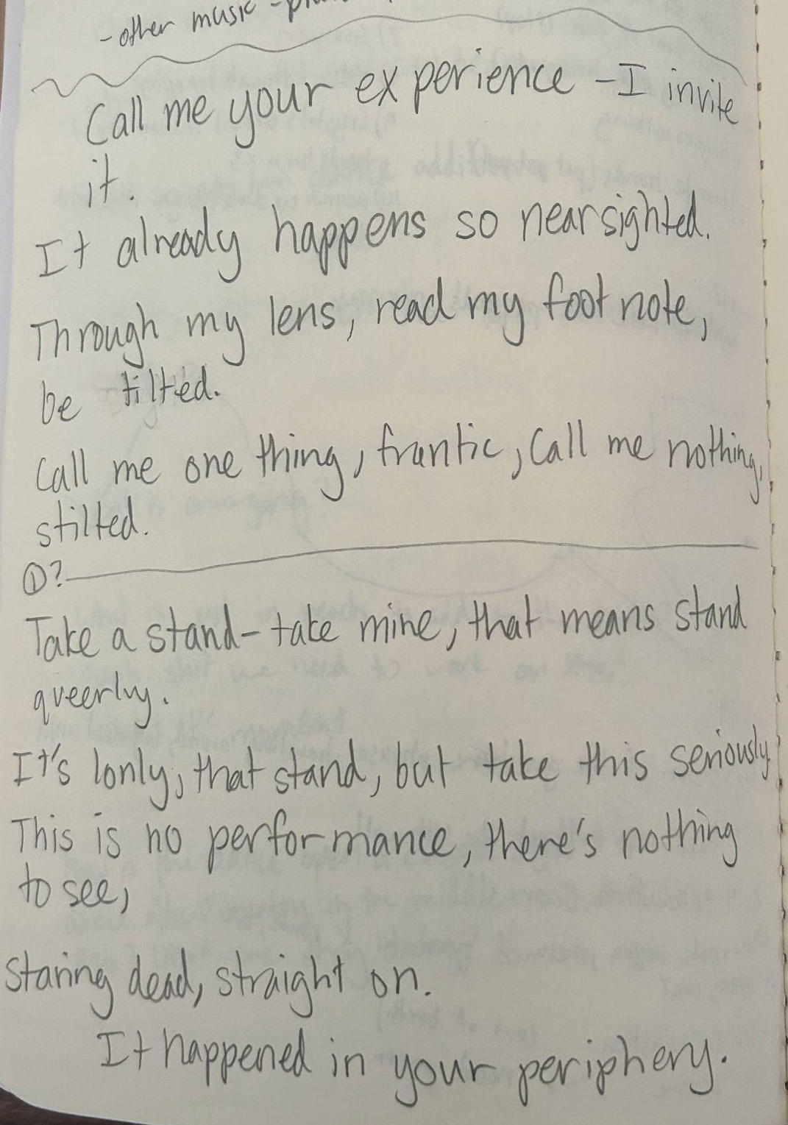
Similar to my gesture catalog, I did a similar exercise by writing a poem over the course it took to read the whole book. It was originally much longer, but I shortened and combined parts to be:
The Counterpane
Take a stand- take mine, that means stand queerly
It’s lonely, that stand, but take this seriously.
This is no performance, there’s nothing to see,
Staring dead, straight on. It happened in your periphery.

Call me your experience- I invite it
It already happens so nearsighted
Through my lens, read my footnote, be tilted
Call me one thing, frantic, call me nothing, stilted

The “stand” ended up becoming literal; my table I use. The first stanza is an invitation to the viewer to join me on my journey and to put themselves at the helm. Whatever interpretation I have of my art is not more important than anyone else's. Indeed, no matter how long this explanation of an essay is, it is all moot. What anyone tries to see through my eyes will still be through themselves too, and that interpretation is just as precious as my own. Let whatever I say roll off your back, “it happened in your periphery.”
The second half of this poem is a bit more personal. One of the main ways I see myself in Ishmael is how, from the first sentence of the book, he opens his story as an invitation to experience all of his trauma and pain. It’s a scary thing to let someone into, much less the added disconnect that anyone can read this book and come away with a different interpretation. I want people to have a unique relationship with my art, but it still hurts to be put into the panopticon of perception. I’ve had to explain myself a lot in life, who I am, what my sexuality is, what my gender is. And I am done with apologizing for when it doesn’t make sense. I want to be frantically myself, I don’t want to be stilted by stepping back and telling people it doesn’t matter if they don’t get it. Instead, I want to give them a chance to walk in my shoes, get pissed off, and maybe one day change their minds. It’s already happening, so why not take charge and have fun with it?
Costumes, Setting, Props: The Nuts and Bolts
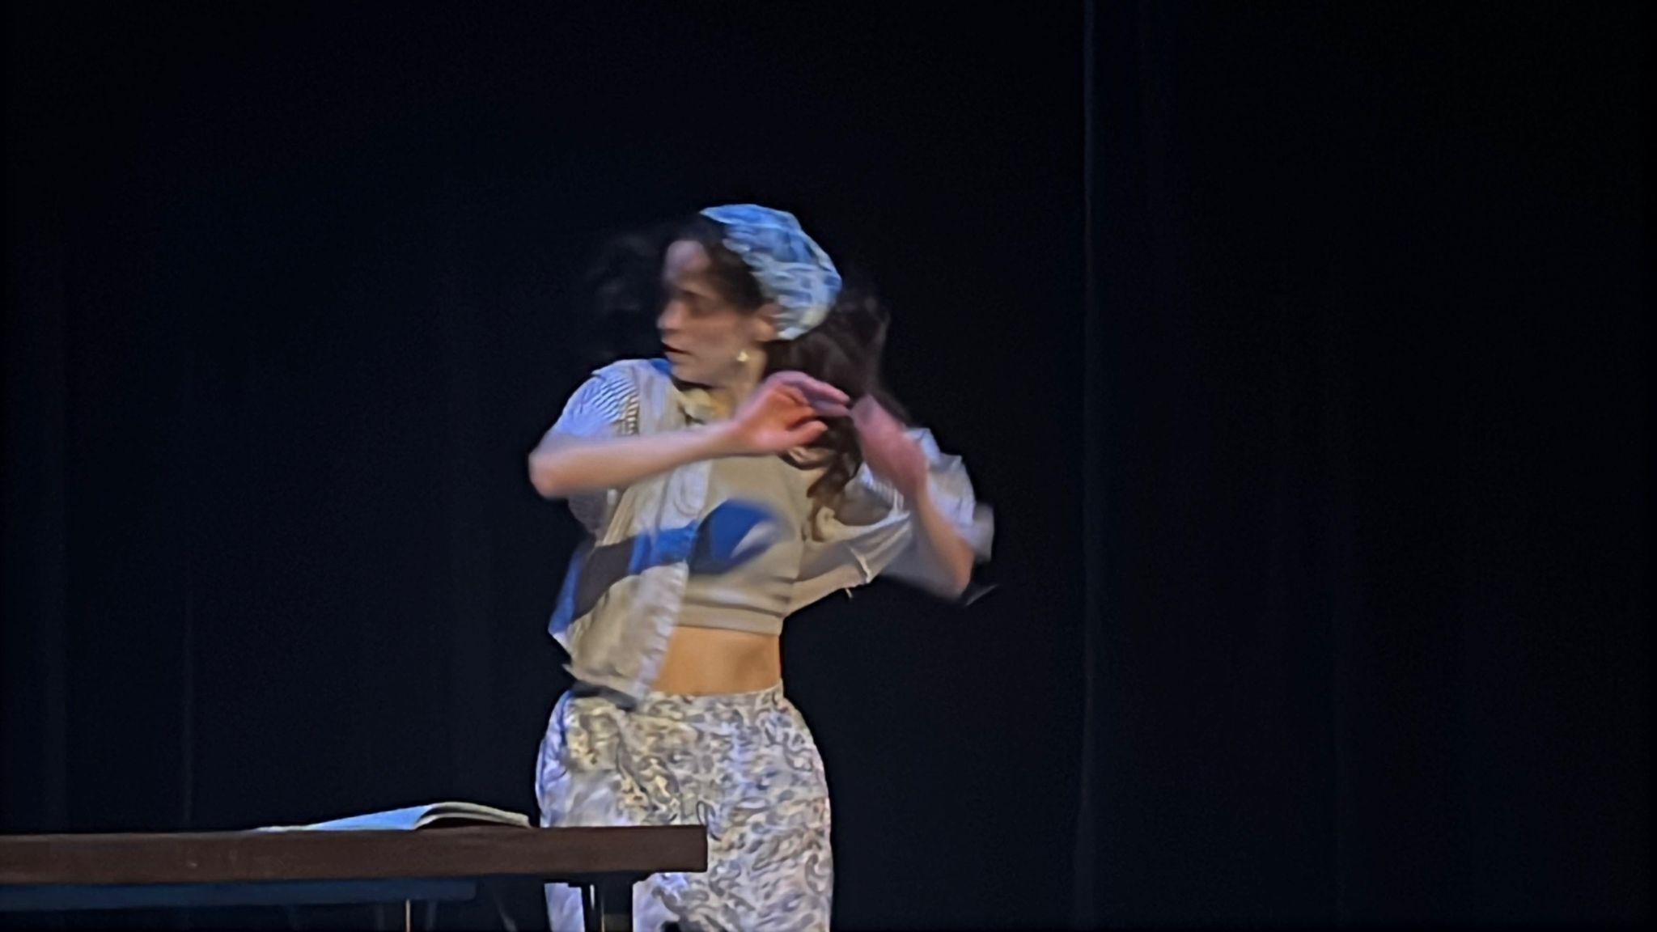
As you can see in this action packed photo, my costume consisted of clashing blue-ish patterns, from my pants to my earrings. Since my goal was to experience my own version of Ishmael’s ordeal, I wanted to literally be the counterpane. It seemed fitting too, knowing that I was inviting others to not only get lost with me, but get lost in me. The notebook and table, slightly visible, are what keep me grounded. I start and end with them; they are my ship, my mast-head, and my soapbox. The table is also a desk, a place where ideas are created and existing stories are written down. This whole project came from different ways of diary-keeping my reactions to the novel, so it seemed fitting to honor that process by referencing in that way.
The Undone Showing, where this was presented, is done in the fall at SDSU and is a place for artists to present works in progress. It’s pretty hard to show projects when they are right in the thick of being made, in their most vulnerable state. Moby Dick is a great book for this showing; it is all things messy, stitched together, full of ideas and characters that are dropped and forgotten. Similarly, this dance is full of all the dead ends I came across while making it, and as a result, it is my account of what happened in this class. By letting it remain unfinished, I acknowledge how I will continue to process Moby Dick long after this project.
My Page in The Showing Program, If You Are Interested
Adding Back in Close Reading: Why State of Mind Is Relevant
This project was a funny process because I finished the whole thing before I really went back and questioned what my inspiration was. I knew it came from my process of reading the whole book, but I needed to make those parts sharper again before I performed it to ensure my close reading was present. This led me back to three chapters: “The Counterpane,” “Stubb Kills a Whale,” and “The Dart.”
Though far apart in the novel, these three scenes are linked by their shared connection to Ishmael’s state of mind. While half awake, half asleep, Ishmael puzzles together with the waking reality that he is in bed with Queequeg, whose arm is now wrapped around him. He works through his emotions, saying,
“My arm hung over the counterpane, and the nameless, unimaginable, silent form or phantom, to which the hand belonged, seemed closely seated by my bedside. For what seemed ages piled on ages, I lay there, frozen with the most awful fears, not daring to drag away my hand; yet ever thinking that if I could but stir it one single inch, the horrid spell would be broken. I knew not how this consciousness at last glided away from me; but waking in the morning, I shudderingly remembered it all, and for days and weeks and months afterwards I lost myself in confounding attempts to explain the mystery. Nay, to this very hour, I often puzzle myself with it.
Now, take away that awful fear, and my sensations at feeling the supernatural hand in mine were very similar, in their strangeness, to those which I experienced on waking up and seeing Queequeg’s pagan arm thrown around me. But at length all the past night’s events soberly recurred, one by one, in fixed reality, and then I lay only alive to the comical predicament.” (Melville 29)
Andrew Delbanco, who I quoted earlier, already said it perfectly, but this is the moment where Ishmael traverses his consciousness to question what this scenario means to him. He could have reacted violently or been disgusted, but instead he accepts it. Being able to navigate this situation by allowing himself to feel his fear and sit with it, he gains mental prowess that will be used later on the ship; “for days and weeks and months afterwards I lost myself.” He does not let this moment go to waste; he continues to grapple with it. Ishmael is choosing to dive deep into what makes him uncomfortable, and once he does that, he finds what lies beneath all that “awful fear.” The word “alive” is especially revealing of the perceived danger. It’s just an arm, it’s just a quilt, and they are just in a bed. Is that such a scary reality anymore? No, in fact, it is quite hilarious.
This takes me to the next scene in “Stubb Kills a Whale,” where Ishmael and the crew are drowsily slipping into idleness, just before a whale appears. Melville writes,
“Ere forgetfulness altogether came over me, I had noticed that the seamen at the main and mizen mast-heads were already drowsy. So that at last all three of us lifelessly swung from the spars, and for every swing that we made there was a nod from below from the slumbering helmsman. The waves, too, nodded their indolent crests; across the wide trance of sea, east nodded west, and the sun over all.
Suddenly bubbles seemed bursting beneath my closed eyes; like vices my hands grasped the shrouds; some invisible, gracious agency preserved me; with a shock I came back to life.” (Melville 307-308)
In a very serene image of everyone, person, ocean, sun and direction all nodding off, Ishmael is only ready to wake because of an “invisible, gracious agency.” Ishmael has some ability to wake quickly out of idleness, which I believe he gained back in “The Counterpane.” Perhaps it is because he has learned how to use his idle state of mind to find new things and accept new ideas that allows him to immediately accept this new reality: a whale is attacking the boat. There is “shock” but there isn’t panic, and once again Ishmael is “preserved” as he is “alive” in “The Counterpane.”
Finally, in “The Dart” Ishmael speaks to the way effort is linked to risk in the life of harpooneers. Melville writes,
“... in the vast majority of failures in the fishery, it has not by any means been so much the speed of the whale as the before described exhaustion of the harpooneer that has caused them.
To ensure the greatest efficiency in the dart, the harpooneers of this world must start to their feet from out of idleness, and not from out of toil.” (Melville 314)
The reason why Ishmael is described as “alive” and “preserved” in the earlier quotes is because he has learned how to be in this state of mind, and come back from it, not from “exhaustion” but “idleness.” It’s not a dream he is waking up from, which would leave him “exhausted,” it’s a state of mind he has accepted as a part of reality, and therefore he is always awake. He hasn’t learned how to make himself productive in this time, his rest is still his rest, it’s that he knows being idle is an important part of learning. In “The Counterpane” he was able to process something while half awake by letting himself be half awake. When he jolts awake in “Stubb Kills a Whale,” he is alert and ready to go because he was previously committed to being at rest. By being present in his rest and his waking, Ishmael is able to adapt, react, and survive.
Experiment Round Two: The Book and Me Combined
The ability to be present in the state you are in is the state of mind I am trying to achieve. At this point in the process, I am contending with not really knowing my gestures and having to sing a song in my head while ignoring the music being played live. My mantra during the performance became Fiona Apple’s repeated lyrics, barely enough space to fit my dancing, so I let each section be what it would be, and I let myself use my notebook while I danced. I even lost the handkerchief in my hair right as the music ended! In a sense, I think this created the perfect run of the dance where I didn’t quite know what was happening, but I was really there. MD Dress Rehearsal.MOV
Though this was just the dress rehearsal run, I knew that I had done what I set out to do. This run of the dance wasn’t a retelling, it was happening right then and there, live. Obviously I had run it a few times before so I could work on some things I remember going well and fix other parts I didn’t think went well, like how much time I spent at the table in the rehearsal run, or noting I had cut off my movements when I took up more of the space. But there is a crystal clear air of effort and live choice making; the confusion, distressess, and elation on my face is palpable. It’s almost as if I had found a way to close read while dancing- explicating a few short lines, over and over again, until I found how they recontextualized the text and read the poem at the end (not pictured in that video).
But, If It Was Perfect: How Could I Do It Again?
It came time to do the show, and I was a little nervous with how well the last run had already gone. How do I do something that was improvised again? The answer is really simple; you don’t and it probably wasn’t actually perfect the first time. And it wasn’t! Reading the poem at the end was preplanned, I didn’t literally have an epiphany while dancing and make up eight lines of rhyming couplets. The moves I was doing had been orchestrated over months of cataloging. So I was left with a final strange revelation that brought me even closer to Ishmael than I had been before: I was going to tell my story to a group of people, a lone survivor with only their mindfulness to thank.
MD Showing Wide Lens.MP4
The Final Experiment: The Audience
Something interesting happened where I realized I only really had a few goes at the dance before it became a retelling of what it was. In the dress rehearsal run before the show, and in my few (maybe four) runs of the dance prior, I actually hadn’t memorized the dance yet and needed to look at the notebook to remember what I was doing. And, in the first four runs, I had my song playing so I didn’t have to think about my sound score as much. However, when the time came for me to do the dance, I had actually memorized most of the moves. I loved my dress rehearsal video because I could see the slight struggle in my face as I fought to read the moves, sing the song in my head, and keep up the growing energy of the dance. When I performed it for real, some of that was added on purpose. However the truth of improvisation is that nothing is truly of that moment. Any single kick has years of training behind it. In all of my runs there was something I made sure was added in, like breathing more if I wasn’t as exhausted when I read my poem, or changing my movements to make them more interesting from their initial creation.
That isn’t to say the dance failed because most of it was premeditated, that’s actually the success of this research. Moby Dick was maybe not as polished and linear as all classic novels are, but it certainly was not written all in one go the first time Melville sat down. And therein lies the connection between writing and my choreographic process. No one but Ishmael and I know what happened between when the story really ended and the retelling began, and what elements were lost or changed in that interim. All the audience knows is what to call us.
From doing this dance I learned a lot about authenticity, and how even though I planned the dance to be a live experience, and I made decisions right then and there, it was still premeditated. I wasn’t making up the story as I went along, I was retelling it. I was reliving it live, different versions of it. Even the first time I did it in rehearsal, I was reliving those moments of experiencing and talking about the book as we read it. And it’s not that it wasn’t authentic, it was an adaptation; different every time. I’d like to think I know how Ishmael feels, telling his story with endless ears and eyes watching. It took off some stress, knowing that I wasn’t actually reliving all the work that went into my dance and this semester. I was only telling its story.
Bows, Flowers, Appreciations
Much thanks for reading this very very long essay! This project has meant the world to me because in it, I have found the core to the research I am most interested in, in combining English and Dance. Thank you of course to my class for being the most creative hilarious minds I’ve ever shared the room with, thank you Dr. Pressman, Josie, Jenna, Leslie, Jess, Kathryn, all my classmates (in English AND Dance) and anyone else I’ve talked an ear off of about Moby Dick. Shoutout Josie, Ilse, Lauren and Sawyer for coming to see me, and my mom, Joe and Birdy for filming me! And, if you read this whole thing and realized I never mentioned the whale, well. It wasn’t ever really about him anyways. Thank you and goodbye!
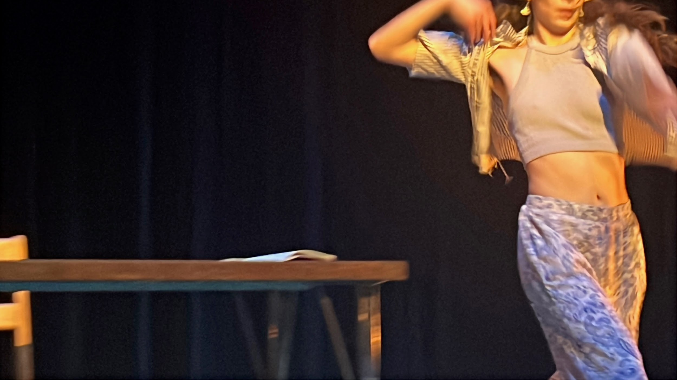

Works Cited
Delbanco, Andrew. Introduction. Moby Dick, by Herman Melville. Penguin Books, 1992.
xi-xxvii.
McGann, Jerome. “The Great Final Hash of Moby-Dick.” Leviathan, vol. 21, no. 2, 2019, pp.
43–67, https://doi.org/10.1353/lvn.2019.0027. Accessed 14 Dec. 2024.
Melville, Herman. Moby Dick. 1851. 2003. Accessed 14 Dec. 2024.

